***HW1***

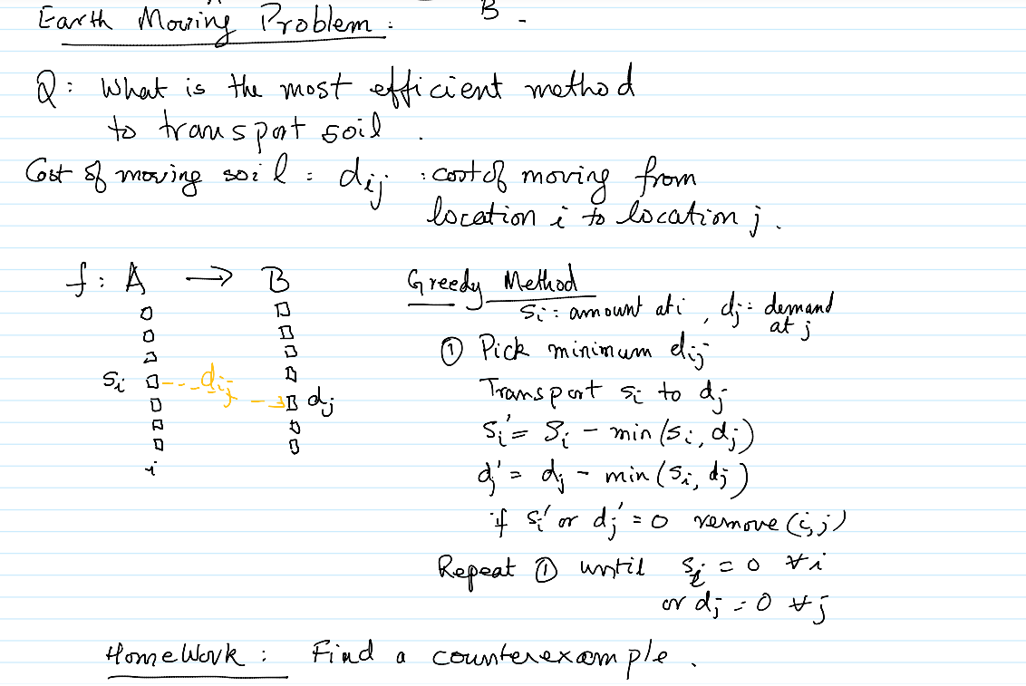

The ***Earth Moving Problem*** is a mathematical optimization problem in which the goal is to figure out the minimum effort needed to change one probability distribution into another. In order to explain it in another way, the Earth Moving problem aims to find the most efficient method for moving two sets of objects from one set to the other, with the least amount of effort, given two sets of objects with different weights and locations. Computer vision, transportation planning, and economics are just a few of the fields where this issue can be encountered.

Let us consider a specific example, with real data, of probability distributions to illustrate the contradiction with the earthwork problem solution by using Greedy algorithms:

Suppose there are two probability distributions A and B:

A = {1, 2, 3} → whose probabilities are: {0.1, 0.3, 0.6}

B = {4, 5, 6} → whose probabilities are: {0.4, 0.5, 0.1}

***Algorithm explanation:***

The Greedy algorithm for the Land Movement problem begins by moving the probability mass from objects in one distribution to objects in the other distribution step by step. At each step, the algorithm moves the probability mass from the object in the first distribution with the highest probability to the object in the second distribution with the highest probability until the entire probability mass is moved. The algorithm assumes that this approach will result in the optimal solution.

The greedy algorithm would start by moving 0.1 probability mass units from 1 to 4, then 0.3 probability mass units from 2 to 5, and finally 0.1 probability mass units from 3 to 6. This results in a ground motion of 0.1 probability mass units. This results in a displacement distance of 0.6.

However, a more optimal solution would be to move 0.1 probability mass units from 1 to 5, 0.3 probability mass units from 2 to 4, and 0.1 probability mass units from 3 to 6. This results in a machine distance of 0.6. This results in an earthwork distance of 0.5, which is less than the solution obtained by the greedy algorithm.

This case illustrates that the greedy algorithm is not always able to provide the most optimal solution to the earthwork problem. This situation highlights the importance of exploring non-greedy approaches to obtain better results, implying that alternative methods might be necessary to solve this problem in the most efficient way.

***HW2***

Suppose that we have a set of workers and a set of jobs, where each worker has a capacity Cw and each job has a cost cwj when being done by worker ‘w’. The objective is to minimize the total cost of servicing all jobs, satisfying the capacity constraint and the requirement that each job be serviced by exactly one worker. To solve this problem, you can use Linear Programming (LP) and follow the steps below:

1. ***Define the decision variables:***

Let xwj be a binary decision variable that indicates whether worker w attends job j (xwj = 1) or not (xwj = 0).

1. ***Define the objective function:***

The objective function is to minimize the total cost of servicing all jobs, which is represented by the sum of the costs cwj for each worker-job pair (w,j). Thus, we can write the objective function as:

***minimize Z = ∑w∑j cwjxwj***

where ∑w and ∑j denote the sum of all workers and all jobs, respectively.

1. ***Define the constraints:***

***a. Capacity constraint:*** Each worker can attend at most Cw jobs. This can be expressed as:

∑j xwj ≤ Cw for all w.

***b.*** ***Job constraint:*** Each job must be serviced by exactly one worker. This can be expressed as:

∑w xwj = 1 for all j.

***c. Non-negativity constraint:*** The decision variables must be binary. This can be expressed as:

xwj ∈ {0,1} for all w and j.

1. ***Solving the LP problem:***

Once the LP problem is defined, we can solve it using any of the linear programming techniques to obtain the optimal solution that minimizes the cost of serving all jobs.

In summary, the Linear Programming problem addresses to minimize the cost function, while serving all jobs and meeting all the constraints. The constraints can be formulated as a binary LP problem with decision variables xwj, objective function Z, and ensuring that each worker does Cw jobs as maximum. Additionally, it must be pointed out that each job is served by exactly one worker, therefore, the ***worker-job*** relationship is ***one-to-many.***